Disease Prediction via Classification
Diabetes Risk Prediction — Analysis Summary
BRFSS 2015 Health Indicators Dataset | Logistic Regression · Random Forest · SVM · XGBoost

1. Objective
Predict the possibility of disease — specifically diabetes — from structured patient/health-survey data, by applying and comparing standard classification techniques: Support Vector Machine (SVM), Logistic Regression, Random Forest, and XGBoost.

2. Dataset
This analysis uses the Diabetes Health Indicators Dataset, derived from the CDC's 2015 Behavioral Risk Factor Surveillance System (BRFSS) survey — the same family of public health datasets referenced by the UCI Machine Learning Repository for diabetes classification tasks. Three CSV variants were supplied:
- diabetes_binary_health_indicators_BRFSS2015.csv — 253,680 records, binary target, naturally imbalanced (~86% no-diabetes / 14% diabetes).
- diabetes_binary_5050split_health_indicators_BRFSS2015.csv — 70,692 records, binary target, down-sampled to an exact 50/50 class balance.
- diabetes_012_health_indicators_BRFSS2015.csv — 253,680 records, 3-class target (no diabetes / pre-diabetes / diabetes).
The balanced 50/50 dataset was used as the primary training/evaluation set for fair model comparison, since a naive classifier on the raw imbalanced data can reach ~86% accuracy while never correctly identifying a diabetic patient. The full imbalanced dataset was then used as a secondary real-world sanity check on the best model (Section 6). The 3-class dataset was used separately in Section 7 to repeat the comparison on the no-diabetes / pre-diabetes / diabetes target, so that all three supplied files are used in this analysis.
Features (21 total) capture self-reported health conditions, behaviors, and demographics — the closest available analogue in this survey dataset to "symptoms / exam results": HighBP, HighChol, CholCheck, BMI, Smoker, Stroke, HeartDiseaseorAttack, PhysActivity, Fruits, Veggies, HvyAlcoholConsump, AnyHealthcare, NoDocbcCost, GenHlth (self-rated general health), MentHlth, PhysHlth, DiffWalk, Sex, Age (bracket), Education (level), Income (bracket). There were no missing values in any file.

3. Methodology
- Stratified 80/20 train-test split on the balanced dataset (random_state = 42).
- Feature scaling (StandardScaler) applied for Logistic Regression and SVM, which are distance/gradient-sensitive; Random Forest and XGBoost trained on unscaled features.
- SVM (RBF kernel) trained on a random 10,000-row subsample of the training data to keep runtime tractable, given the O(n²)–O(n³) cost of kernel methods; evaluation was still performed on the full held-out test set.
- Random Forest: 300 trees, max depth 12. XGBoost: 300 estimators, max depth 6, learning rate 0.1, subsample/colsample 0.8.
- Evaluation metrics: Accuracy, Precision, Recall, F1-score, and ROC-AUC — reported together since accuracy alone is misleading for medical/imbalanced classification.

4. Model Comparison
All four models were trained and evaluated on an identical stratified split of the balanced dataset. Results, sorted by ROC-AUC:
Model | Accuracy | Precision | Recall | F1-score | ROC-AUC
Random Forest | 0.749 | 0.728 | 0.7949 | 0.76 | 0.8283
XGBoost | 0.7497 | 0.7304 | 0.7915 | 0.7597 | 0.8274
Logistic Regression | 0.7458 | 0.7372 | 0.7639 | 0.7503 | 0.8232
SVM | 0.745 | 0.7187 | 0.8051 | 0.7595 | 0.8146

Random Forest achieved the highest ROC-AUC, though all four models perform closely (ROC-AUC 0.81–0.83), indicating the ceiling here is largely set by the predictive signal available in self-reported survey features rather than by algorithm choice.
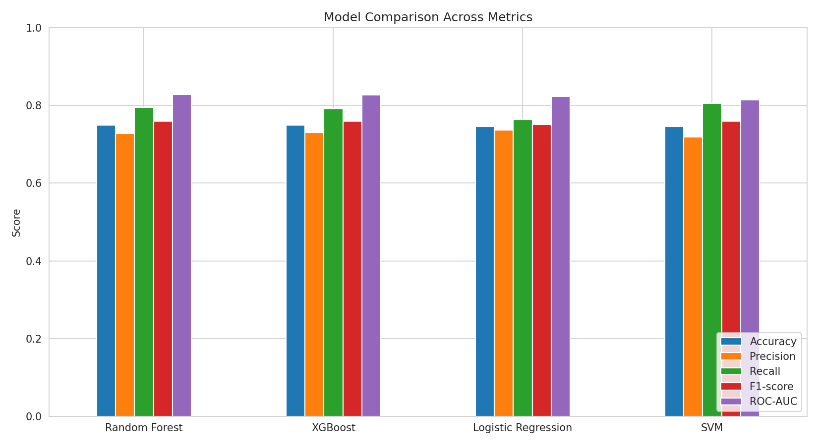
Figure 1 — Accuracy, Precision, Recall, F1-score and ROC-AUC across all four models.
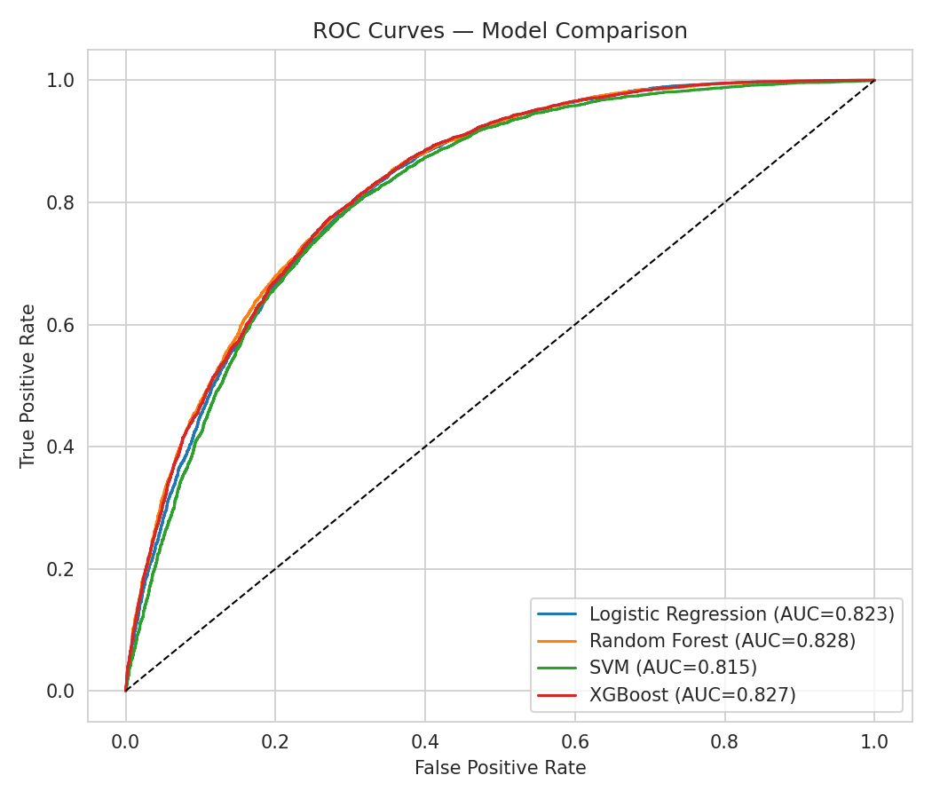
Figure 2 — ROC curves for all four models (diagonal = random-chance baseline).

5. Confusion Matrices & Feature Importance
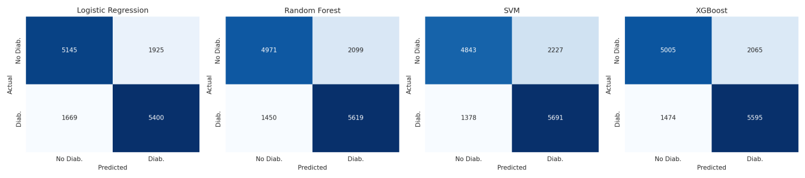
Figure 3 — Confusion matrices on the held-out test set (rows = actual, columns = predicted).
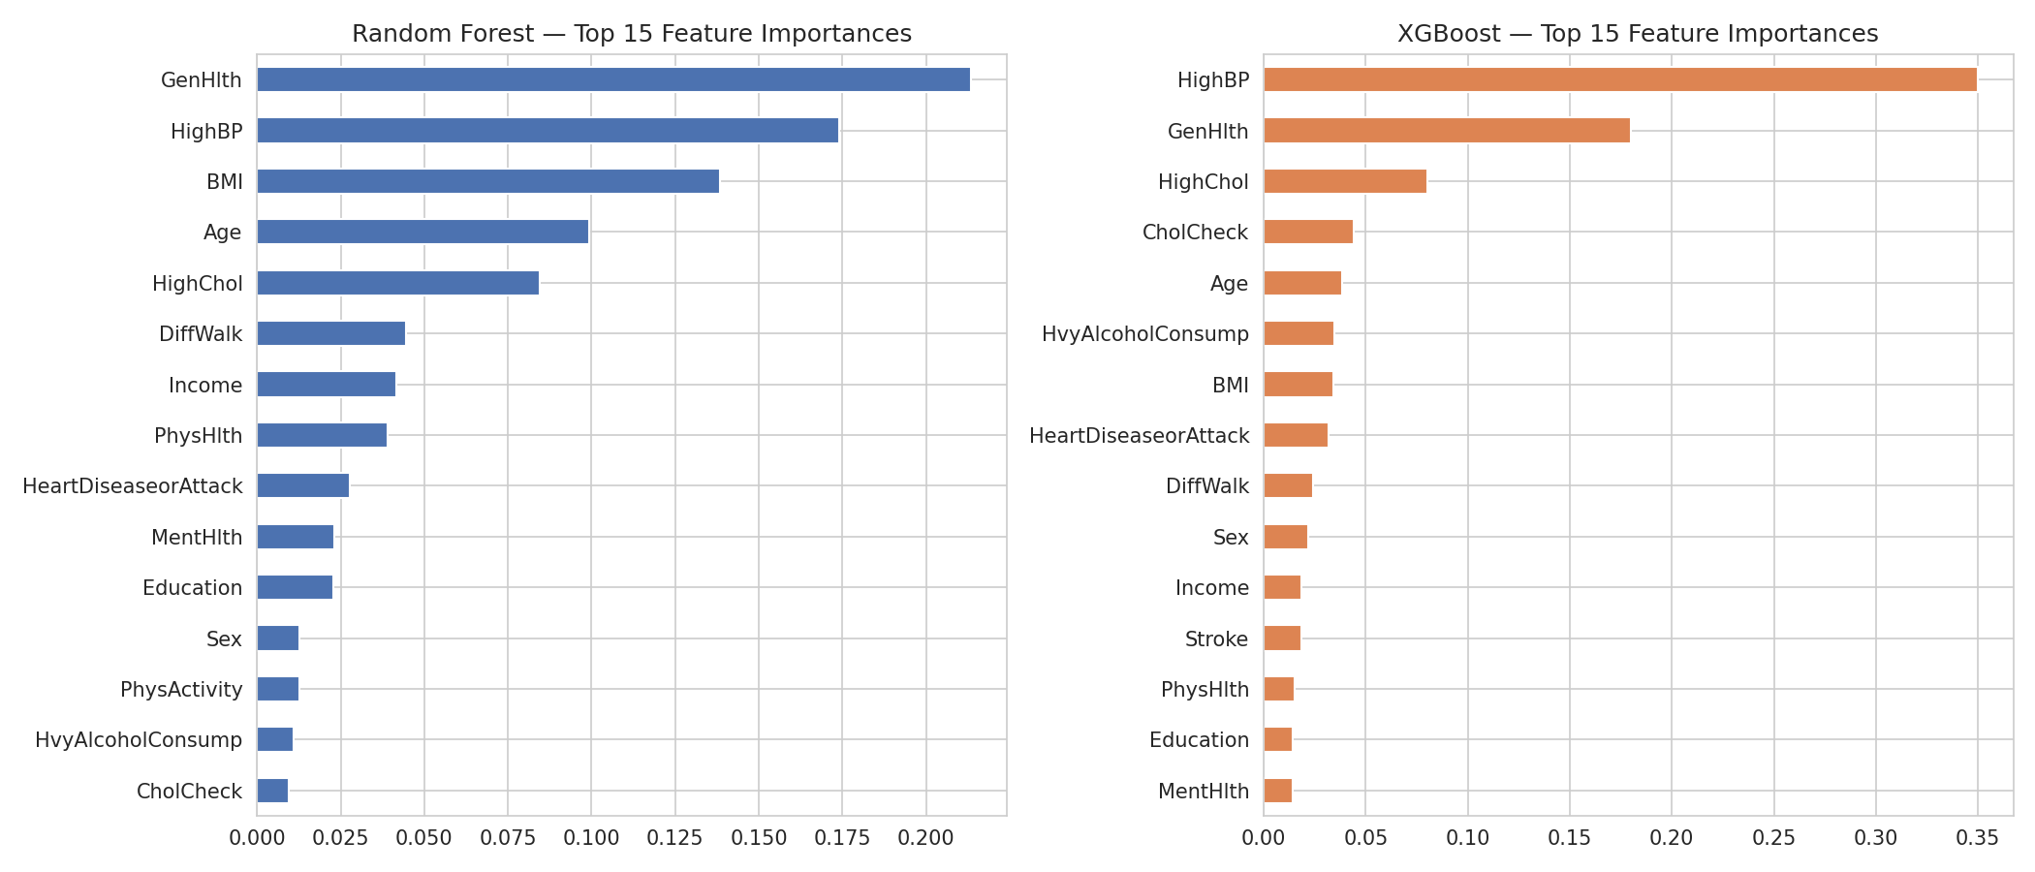
Figure 4 — Top 15 feature importances, Random Forest (left) vs. XGBoost (right).
Both tree ensembles consistently rank GenHlth (self-rated general health), BMI, Age, HighBP, HighChol, Income, and DiffWalk among the strongest predictors — consistent with established clinical risk factors for type-2 diabetes (obesity, hypertension, hypercholesterolemia, age, and reduced physical function).

6. Real-World Sanity Check (Imbalanced Data)
The best-performing model (Random Forest) was re-evaluated on a held-out split of the full, imbalanced BRFSS dataset (~86%/14% class ratio) to gauge real-world generalization:
- Accuracy: 0.7263 (rises — driven mainly by the majority "no diabetes" class)
- Precision: 0.3159 (drops sharply — many false positives once diabetic cases are rare)
- Recall: 0.8271 (stays strong — the model still catches most true diabetic cases)
- F1-score: 0.4572
- ROC-AUC: 0.8471 (in line with the balanced-data result, since AUC is threshold/imbalance-robust)
This confirms the model's discriminative ability (ROC-AUC) transfers well to the real class distribution, but that a fixed 0.5 decision threshold trades away precision for recall in this setting — expected and often acceptable in a screening context, where missing a true diabetic case (false negative) is costlier than an extra follow-up test (false positive). A production deployment should tune the decision threshold to the desired clinical precision/recall trade-off rather than defaulting to 0.5.

7. Multiclass Analysis (3-Class Dataset)
The third supplied file labels patients into three classes: no diabetes, pre-diabetes, and diabetes. Unlike the binary file, it is not pre-balanced. The same four algorithms were retrained on this target (with class-weighting to compensate for imbalance) so that all three provided datasets are used in this analysis.
Model | Accuracy | Balanced Accuracy | Precision (macro) | Recall (macro) | F1 (macro)
Random Forest | 0.712 | 0.503 | 0.4321 | 0.503 | 0.4364
SVM | 0.6644 | 0.4906 | 0.4261 | 0.4906 | 0.4177
XGBoost | 0.8485 | 0.3882 | 0.4692 | 0.3882 | 0.3989
Logistic Regression | 0.8455 | 0.3829 | 0.4587 | 0.3829 | 0.3916

Accuracy alone is misleading here — Logistic Regression and XGBoost reach ~84–85% accuracy simply by leaning on the dominant "no diabetes" class, while macro-F1 (which weights all three classes equally) is far lower for every model. By macro-F1, Random Forest performs best, but all four models share the same weak point below.
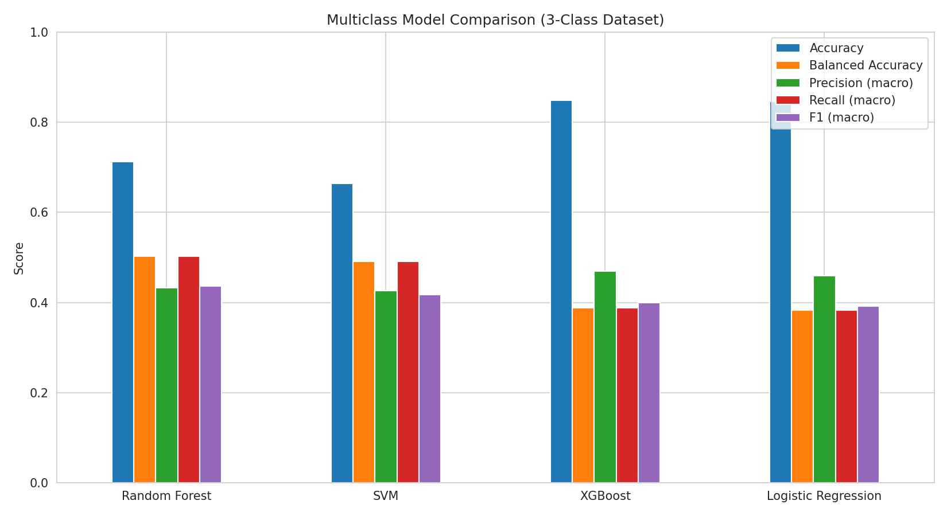
Figure 5 — Multiclass comparison: accuracy, balanced accuracy, and macro precision/recall/F1.
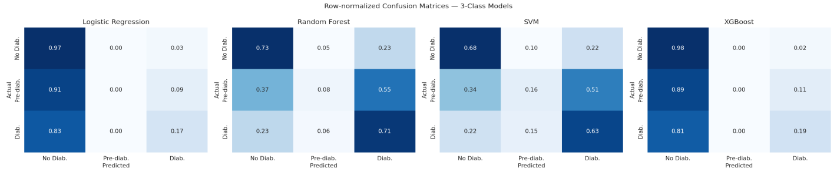
Figure 6 — Row-normalized confusion matrices, 3-class models (rows = actual, columns = predicted).
Every model struggles to identify the pre-diabetes class: most pre-diabetic patients are predicted as "no diabetes" instead. This is a known characteristic of this dataset — pre-diabetes is both a small minority class and clinically similar to its neighbors on these survey features — rather than a weakness of any one algorithm. Practically, this means the binary framing (Sections 1–6, diabetes vs. no-diabetes) remains the more useful model if the goal is reliably flagging at-risk patients; the 3-class model is included here for completeness since it was one of the three supplied datasets.

8. Conclusions & Recommendations
- All four algorithms are viable for this task; Random Forest and XGBoost hold a small, consistent edge over Logistic Regression and SVM on ROC-AUC and F1-score.
- Recall (sensitivity) is the most clinically relevant metric for a screening tool of this kind — it should be prioritized over raw accuracy.
- The dominant predictive features (GenHlth, BMI, Age, HighBP, HighChol) match known clinical risk factors, giving confidence the models are learning genuine signal rather than spurious correlations.
- Accuracy on the natural, imbalanced population is a poor standalone metric; report precision/recall/ROC-AUC together, and consider resampling or class-weighting strategies (as done here) or a cost-sensitive threshold.
- Recommended next steps: hyperparameter tuning via cross-validation, probability calibration, testing with additional clinical variables (e.g. HbA1c or fasting glucose, if available) to complement survey-based features, and external validation on an independent cohort.
- The 3-class extension confirms the binary framing is the more practically deployable one for this dataset, since every algorithm struggles to separate the rare pre-diabetes class from its neighbors.

